ENTERPRISE SERVICE BUS INTEGRATION (BIZTALK SERVER 2013 R2)

To get a perspective and context for this document, please read and consider the following two files:

1. Architecture Modeling Nov-19.vsdx (Visio file)
2. OuiDeliver Simple Order Sequence Diagram (PDF file)
   1. We will only detail the integration of the green component which is the integration with the Enterprise Bus Service and the BizTalk Application Server for the Order Manager Service

WORKFLOWS

TYPE OF ORCHESTRATION

INTERPHASES

PHYSICAL SETUP

MESSAGE SCHEMA

Message Schemas are usually validated against particular Use Cases in the requirements. In our example we will need at least the following Schemas:

Biztalk communication adapters (http, ftp, etc)

Biztalk received files and convert to XML to send to other system

Biztalk convert messages to make Web Service Calls

Biztalk orchestration and business rule engine

Make a diagram

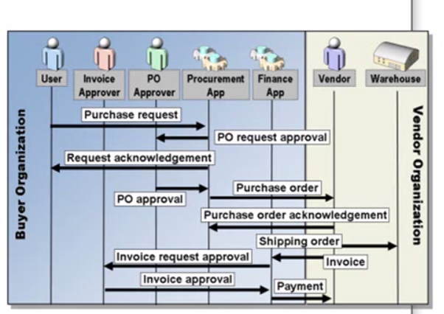

Biztalk receive adapters (…) must have a port #

Biztalk receive pipeline (gets the message, makes an object instance and make modifications to the message if needed [decryption or validate digital signature, or examine the content and extract data]), then it would map incoming files or messages and convert to xml files for internal communication.

Look at Biztalk Messages types and subscribers interested in types of message.

Biztalk sending ports and look at map for type of messages

